**Part I: Interview**

time:

4 minutes

Teacher:

*In the first part of this test, I am going to ask each of you some questions.*

*In the interview,* ***I will ask each of you*** *each* ***question*** *in the following way:  
A, then B / B, then A / A, then B … and so on.*

*We will start when you are ready.*

* What can you tell me about yourself and your family?
* Which is your favourite subject and why?
* Are there any subjects you don't like? Why?
* What kind of media do you use?
* Do you have any favourite film or series?

*This is the end of this task.*

**Part II: Monologue A**

Teacher:

*Now I'd like each of you to* ***talk about pictures****. You have about* ***2 minutes each****.*

**Candidate A***: You will start. Here is your material.*

time:

2 minutes

* Describe one of the pictures.
* How might the person in the picture feel and why?
* What kind of food do you prefer?

*Shall I repeat the instructions?*



**Candidate B***: Now it's your turn. Here is your material.*

time:

2 minutes

* Describe one of the pictures.
* How might the people in the picture feel and why?
* In which situations do you prefer to use or not to use your smartphone and why?

*Shall I repeat the instructions?*

**

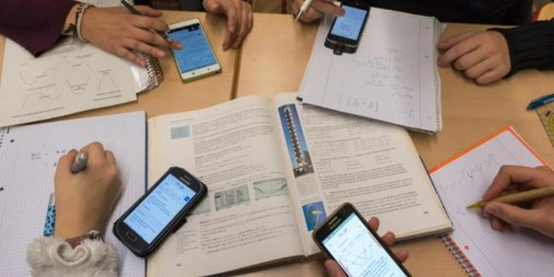

**Part III: Paired Discussion**

time:

4 minutes

Teacher:

*Now I'd like each of you to* ***talk to each other****.*

You and your friend are planning a holiday in the USA. You can stay in a big city or in the country. Use the pictures to discuss the pros and cons of holidays in a big city or in the country.

**

